

**EARLY LEARNING FUND**

**1707 STONE STREET FALLS CITY, NEBRASKA 68355**

**402-245-3276**

**Falls City Public Schools**



**STAFF**



**October**

Hello All,

My name is **Kelsey Prichard.** I was born and raised here in Falls City, NE. I attended Peru State College and graduated in December of 2019 with a Bachelors in Educational Studies.

Throughout college I worked at Dickeys Barbecue Pit until I graduated. I then started working with SENCA Head Start as a teacher aide then advanced into a Head Teacher for the

organization.

Through that organization I have gained about 3 years of professional experience working with young children and families. I am extremely grateful I have the opportunity to work at Sixpence with you all, and I hope to build a wonderful relationship with each of my families. I know that we can achieve great things!

**Susan Johnson—**

Director

Sixpence & Child Care Partnership

**Amber Ramer—**

Family Educator

**Susan Witt—**

Childcare Partnership Step-Up to Quality Coach

**Sandra McNeely—**

Family Educator

**Kelsey Prichard—**

Family Educator

**Home Visiting**

Number of families: 31

Number of children: 36

Unborn babies: 3

**Childcare Partnership**

Serves 7 daycares and 1 center.

**October Parent Meeting**

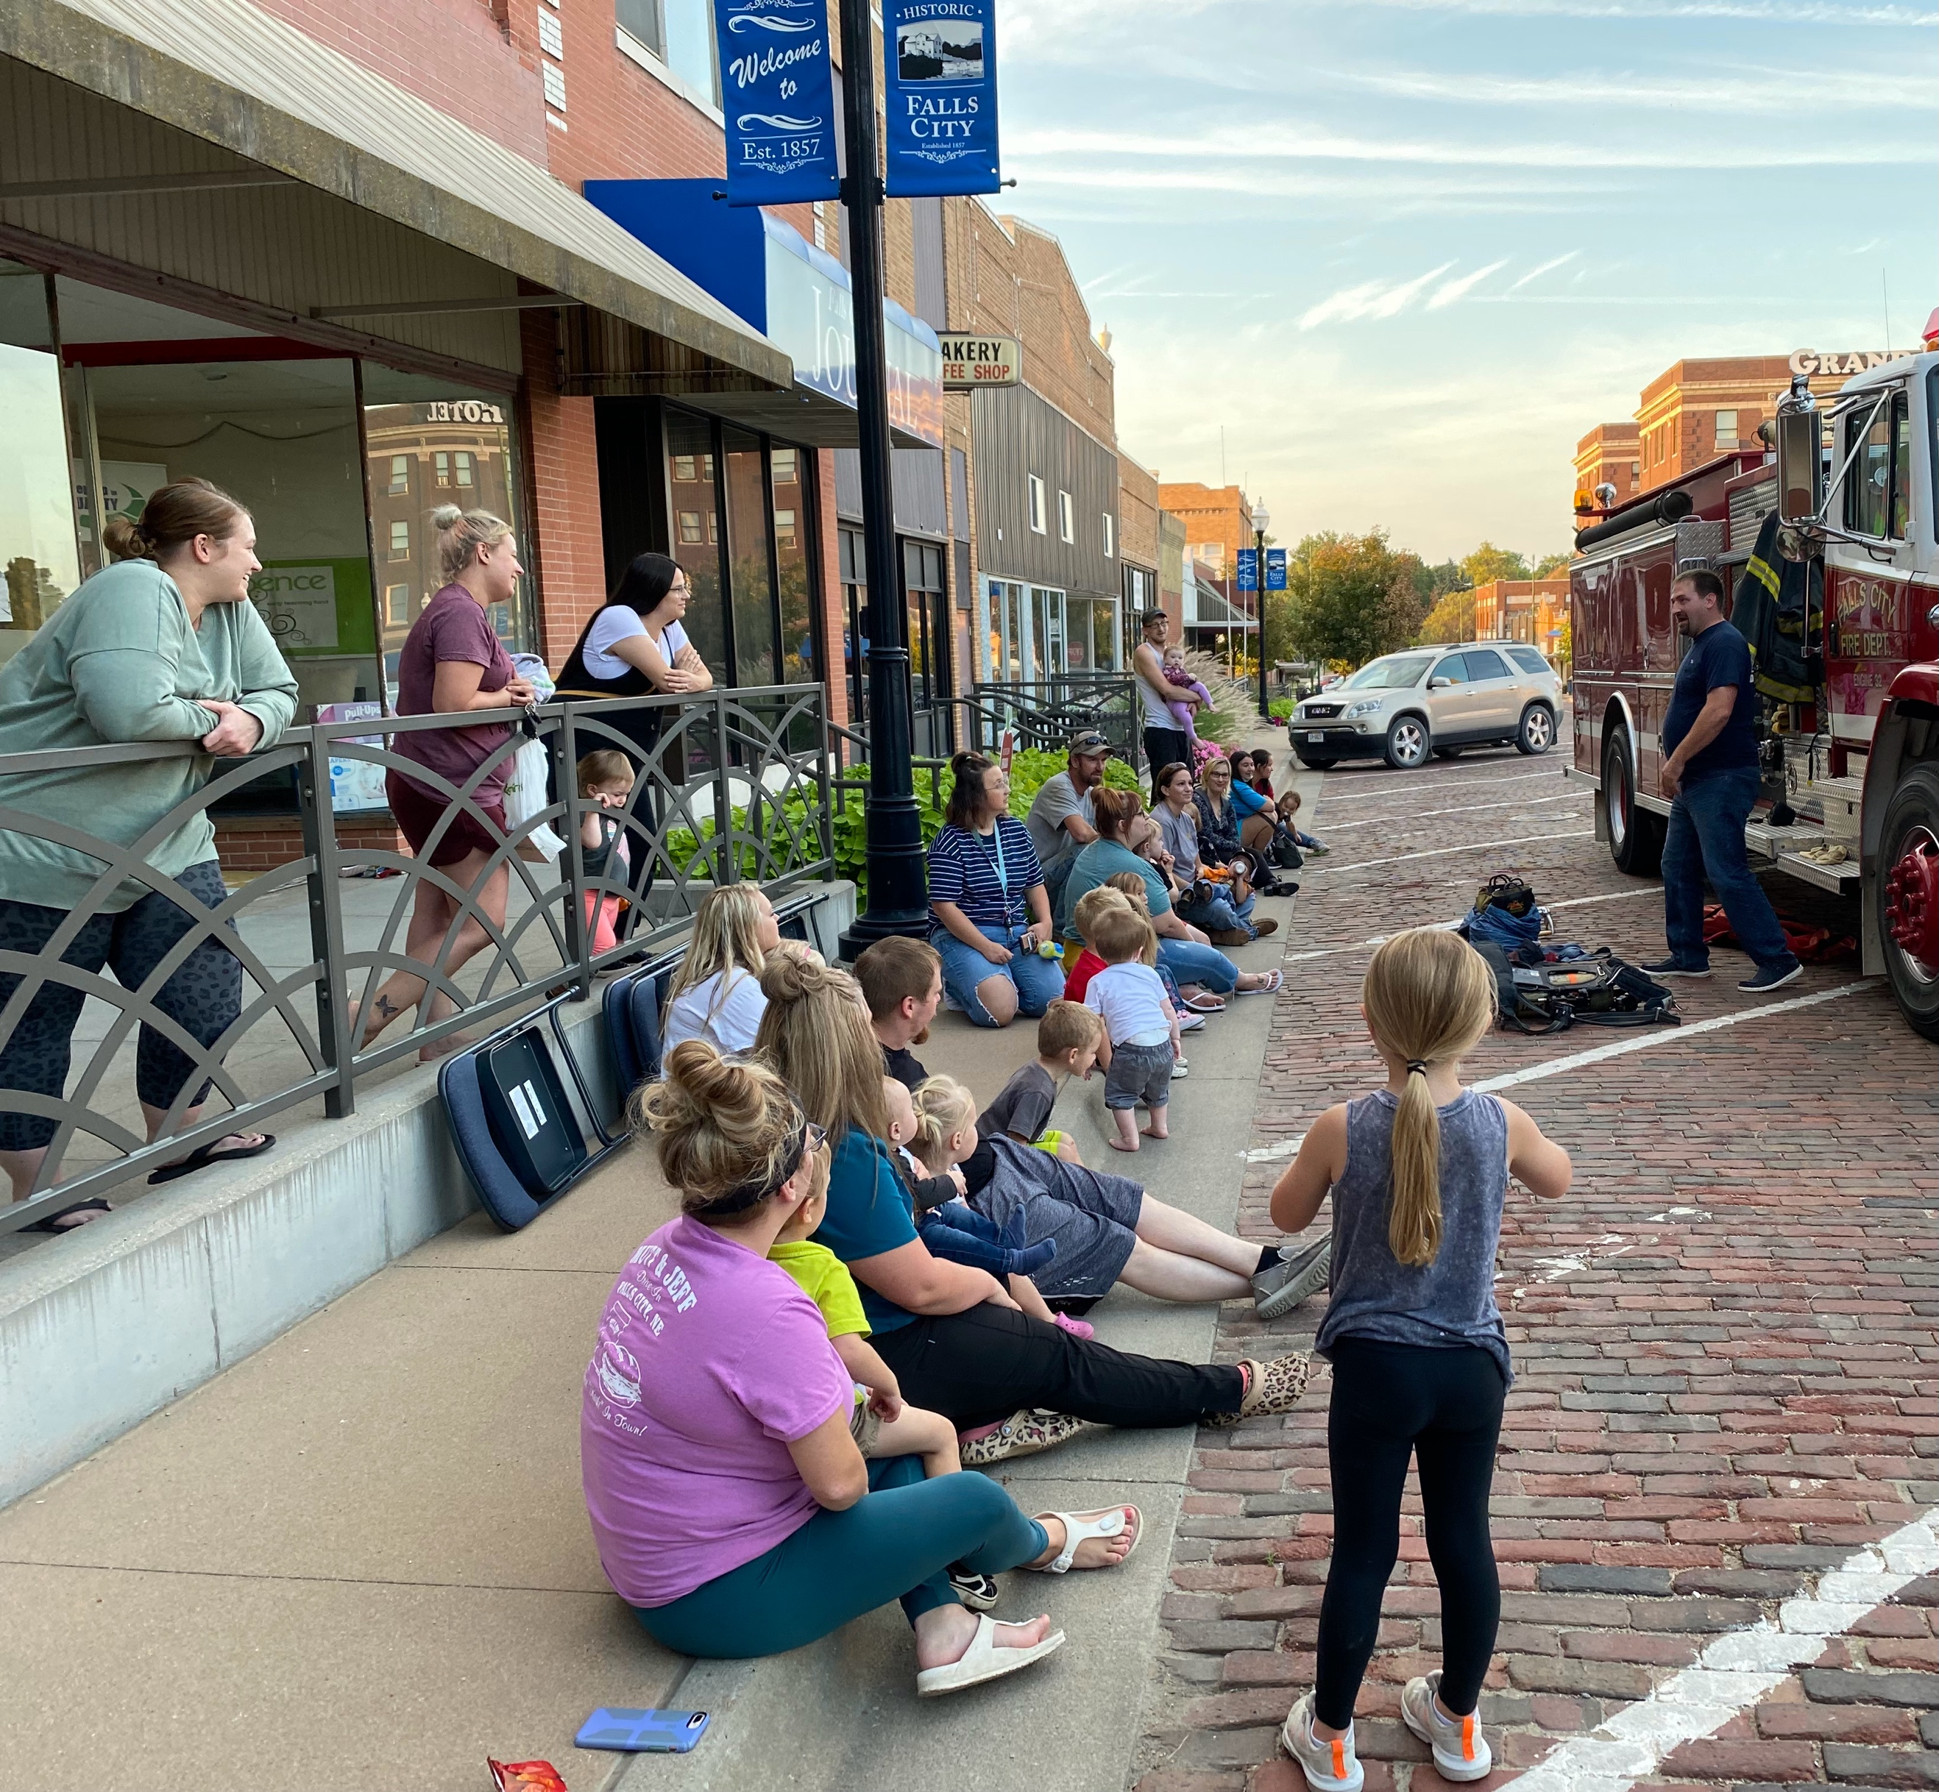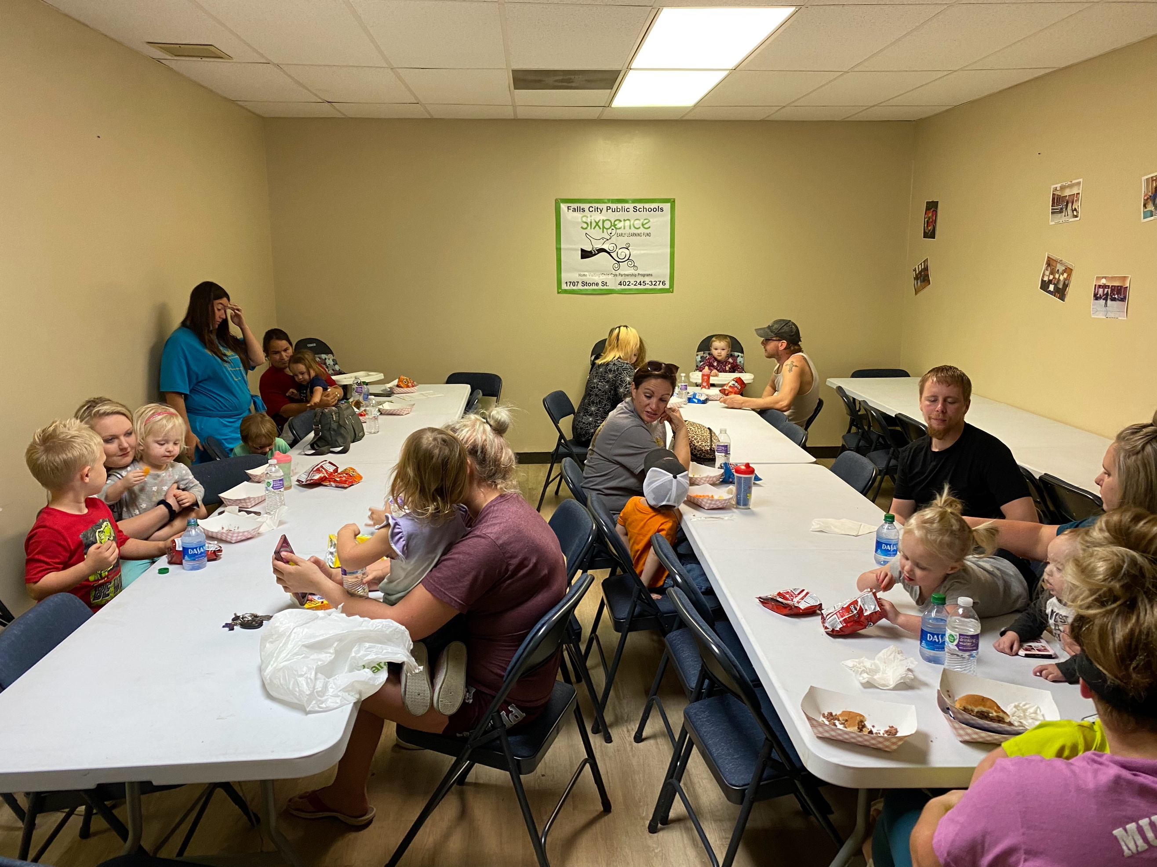

Parents and children learning Parents and children enjoying

from fireman Daniels about fire supper before the fireman arrives.

safety.__________________________________________________________________

At the Fire Safety meeting we had approximately 40 people in attendance.

The children and families enjoyed socializing, eating, playing, & learning about staying safe during a fire.

Each family received a digital thermometer, and a book “The Wheels on the Fire Truck”from Sixpence. A frisbee with candy and stickers were given to the children from the fireman.

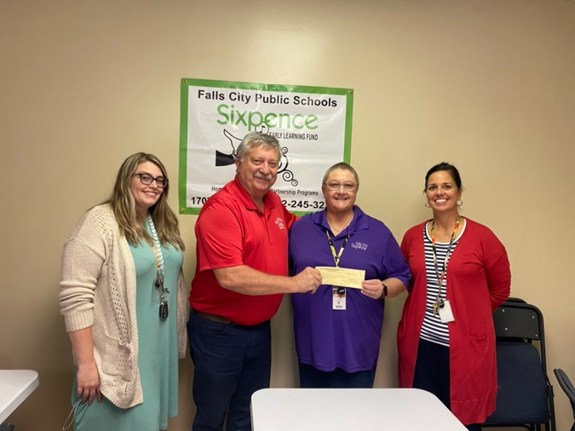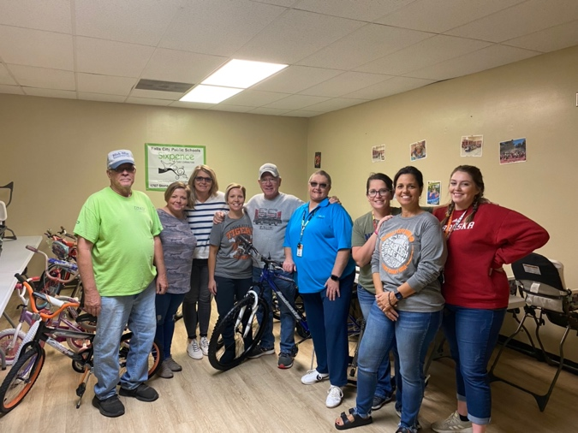

**BIKE MAN STRIKES AGAIN…**

Thank you does not even seem adequate when Larry Cook arrives with bikes for the Falls City Community. Today we were blessed with 22 bikes to give away.

Thank you, Larry, for your generosity to our program. In the photo left to right. Jim Cook, Heather Gill, Susan Witt, Jenny Binder, Larry Cook, Susan Johnson, Amber Ramer, Sandra McNeely, Kelsey Prichard.

**THANK YOU, THANK YOU, THANK YOU.**

Thank you to the Falls City Elks Club for the WONDERFUL **$2,500** donation to our program. We really appreciate what you do for children and families.

In the photo left to right: Kelsey Prichard Sixpence/Roger Lampe FC Elks Club/Susan Johnson Sixpence/ Sandra McNeely Sixpence

**Sixpence Count**

|  |  |  |  |  |  |  |
| --- | --- | --- | --- | --- | --- | --- |
| **November 2021** | | | | | | |
| Monday | Tuesday | Wednesday | Thursday | Friday | Saturday | Sunday |
| 1 | 2 | 3 Circle Of Security Parenting Class 6:30 | 4 | 5 | 6 | 7 |
| 8 | 9 | 10 Circle Of Security Parenting Class 6:30 | 11 Veterans Day  United States of America Flag PNG Transparent Images | PNG All  **Arts & Crafts**  **9:00 – 6:00** | 12 | 13 | 14 |
| 15 **Holiday Gift and Food Basket Forms are due!** | 16 **Parent Meeting**  **Topic: Communication**  **Supper at 6:00**  **Speaker at 6:30**  **Jamie Jacobs** | 17 Circle Of Security Parenting Class 6:30 | 18 **Child Care Partnership Meeting**  **5:45**  **Speaker at 6:00**  **Jamie Jacobs**  **Yoga to follow**  **Charity Zimmerman** | 19 | 20 | 21 |
| 22 | 23 | 24 Circle Of Security Parenting Class 6:30 | 25 Thanksgiving Day  Turkey bird PNG**Sixpence Closed** | 26 Sixpence Office Closed | 27 | 28 |
| 29 | 30 |  |  |  |  |  |

**2021**