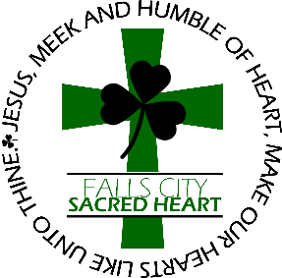
Falls City Sacred Heart Catholic School
1820 Fulton Street, Falls City, NE 68355 402.245.4151

Application for Enrollment

Name of Student enrolling Date of Birth Grade Level Date

___________________________________________ _________________ _____________ ____________________
First Middle Last

Family last name: ____________________________________________Home phone number: _______________________________

Address: __________________________________City: _________________________State: _____________Zip Code: __________

Father’s name: ______________________________ Father’s cell phone: _________________________________
Father’s Employer: ___________________________ Employer’s phone number: ___________________________
Father’s email: _____________________________________________

Mother’s name: _____________________________ Mother’s cell phone: ________________________________
Mother’s Employer: __________________________ Employer’s phone number: ___________________________
Mother’s Email: ____________________________________________

Residing with: ______________________________________________

Public School District: ___________________________County_______________________________________________________

Baptism First Confession First Communion Confirmation
Date: __________________ _________________ __________________ ______________
Church: __________________ _________________ __________________ ______________
City, State: __________________ _________________ __________________ ______________

Ethnicity: No, not Hispanic/Latino

Yes, Hispanic/Latino (a person of Cuban, Puerto Rican, South or Central American or other Spanish culture or origin, regardless of race)

Race: (please circle) American Indian/Alaska Native Asian Black or African American
Native Hawaiian or other Pacific Islander White Other
ALERT NOW:
If you have previously provided this information for an older child and there are no changes, you do NOT have to resubmit. Please fill in your family name and mark “No Changes”

NO CHANGES
School Communication/Alert Now

I would like to receive the daily bulletin via email at the following address:
_____________________________________________________

This is a new email address

Alert Now: Keeping you informed is a top priority. Using the Alert Now notification system, you will be notified of
school cancellations and delays due to inclement weather, as well as reminders for upcoming events. Caller ID will display
Sacred Heart School or phone number 402-245-4151. Alert Now will leave messages on any answering machine. The
successful delivery of Alert Now depends on accurate information for students. Please make sure we have the most recent
phone numbers and if you have changes, please notify the school.

Family Name: ___________________________________

Student (s) Name (s): _____________________________________________________________________________________________________

Phone #1: ____________________________

Phone #2: ______________________________

Phone #3: ______________________________

